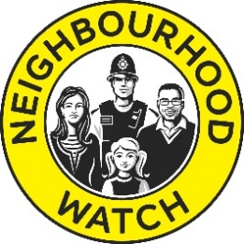
Neighbourhood Watch
In Greenwich Borough
Registration & Consent form

Thank you for joining Neighbourhood Watch.

The below information will be used by your local Neighbourhood Watch Coordinator and Greenwich Borough Neighbourhood Watch and Neighbourhood Policing Team to administer your Neighbourhood Watch Scheme and send you crime prevention messages and information and newsletters relevant to the work of Neighbourhood Watch.

JOINING THE NATIONAL NEIGHBOURHOOD WATCH SCHEME REGISTER
With your consent, it will also be shared with the Neighbourhood Watch Network to send you newsletters, crime prevention information from our partners and information and the occasional survey relating to the work of Neighbourhood Watch nationally. In this case your details will be entered onto the national Neighbourhood Watch Scheme Register which is processed on our behalf by Visav Ltd. Any information you give below will NOT be shared with anyone else or used for any other purpose without your explicit consent, in line with GDPR regulations.

Please complete in BLOCK CAPITALS the details below and return to your Neighbourhood Watch Coordinator or alternatively register to join your local Neighbourhood Watch Scheme via email to greenwichnhwnetwork@gmail.com or via www.ourwatch.org.uk.

TITLE | MR/MRS/MISS/MS/REV |  | FULL NAME
DATE OF BIRTH |  |  | ETHICITY: (OPTIONAL)
HOME ADDRESS INC POSTCODE
HOME PHONE NUMBER |  | MOBILE PHONE NUMBER
EMAIL ADDRESS:
Please tick if you agree

- I agree for Neighbourhood Watch to use my details for Neighbourhood Watch purposes outlined above.
- I agree to receive messages and newsletters from my local Neighbourhood Watch scheme in (force area).
- I agree for my details to be added to the national Neighbourhood Watch Scheme Register and to receive messages and newsletters from Neighbourhood Watch Network.

SIGNED: __________________________________ DATE: __________________________________

If, in the future, you wish to update the details you have given above or have your data removed from Neighbourhood Watch records please contact greenwichnhwnetwork@gmail.com. or log into your account on the Ourwatch website (if you have one) https://www.ourwatchmember.org.uk/.

My preferences to contact me are: Post ☐ Email ☐ Telephone ☐ Text message ☐

